EXERCISE 2
public class Order {
private int orderNum;
private double orderAmount;
private double orderDiscount;

public Order(int orderNumber, double orderAmt, double orderDisc) {
orderNum = orderNumber;
orderAmount = orderAmt;
orderDiscount = orderDisc;
}

public double getOrderAmount() {
return orderAmount;
}

public double getOrderDisc() {
return orderDiscount;
}
}

public class CustomerOrder {
public static void main(String[] args) {
int ordNum = 1234;
double ordAmount = 580.00;
double discountPer = 0.12;
Order order = new Order(ordNum, ordAmount, discountPer);

double finalAmount = order.getOrderAmount() * order.getOrderDisc();
System.out.println("Final order amount = $" + finalAmount);
}
}

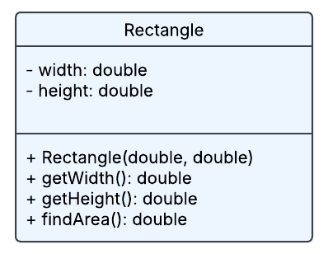

EXERCISE 3
Program 1
Before calling change:
a1 a2 a3
111 222 333

Before changing the values:
f1 f2 f3
111 222 333

After changing the values:
f1 f2 f3
999 888 777

// Program 2
class Trial {
private int a;
private String b;

Trial(int a) {
this.a = a;
b = "0";
}

public void setAB(int num, String str) {
a = num;
b = str;
}

private int getA() {
return a;
}

public void show() {
System.out.println("A: " + getA());
System.out.println("B: " + b);
}
}

class TrialTest {
public static void main(String[] args) {
Trial ac = new Trial(5, "Five");
ac.a = 10; // This will cause an error (a is private)
ac.b = "Ten"; // This will cause an error (b is private)
ac.setAB(6, "Six");
ac.getA(); // This will also cause an error (getA is private)
ac.show();
}
}

